**FlashQuiz: An Interactive Flashcard-Based Learning and Review Tool**

**Andrei Sebastian P. Baltazar, Hanz Mikhail V. Bañas, Jerico Joir V. Bernasol D*e La Salle University***

***Gokongwei College of Engineering***

**Malate Manila, Philippines** [**andrei_baltazar@dlsu.edu.ph,**](mailto:andrei_baltazar@dlsu.edu.ph) [**hanz_banas@dlsu.edu.ph,**](mailto:hanz_banas@dlsu.edu.ph) [**jerico_bernasol@dlsu.edu.ph**](mailto:jerico_bernasol@dlsu.edu.ph)

***Abstract*:** The FlashQuiz is a Java-based interactive quiz program designed to help users learn and test their knowledge using flashcards. With the help of the program, users can make and manage flashcards that contain unique questions and solutions. Users can launch a quiz session where flashcard questions are shown and they must respond with the correct information to demonstrate their understanding. The program monitors user scores and gives immediate feedback on whether the answers are correct. FlashQuiz also allows users to save and load flashcards to/from files for later use. Additionally, the FlashQuiz supports saving and loading flashcards to/from files for future use. The user interface incorporates the ACM graphics library for a visually appealing experience. Through this FlashQuiz program, users can engage in an efficient and interactive learning process.

**Keywords:** Java, Flashcards, Quiz, ACM Graphics, Interactive, Learning, Education, User Scores, File I/O, Swing Dialogs, Feedback.

1. **Introduction**

This documentation provides a comprehensive overview of FlashQuiz, an innovative study aid program that improves knowledge retention and fosters engaging learning experiences for students. By enabling the creation of personalized flashcards and quizzes, FlashQuiz facilitates self-assessment and reinforces subject understanding. Incorporating a competitive edge through the leaderboard and score calculator, the program encourages

academic excellence and competitiveness among fellow learners.

With sustainable development goal #4: Quality Education in mind, FlashQuiz was born out of a collective ambition to address the challenges faced by students in retaining information effectively after learning various subjects or lessons. Recognizing the significance of continuous review and self- assessment in the learning process, our team embarked on a mission to create an interactive and user-friendly platform that leverages the proven effectiveness of

flashcards for enhanced knowledge retention.

Our primary objective in developing FlashQuiz was to offer a versatile tool that caters to diverse learning styles and needs. Whether students prefer visual, auditory, or kinesthetic learning, the program accommodates these preferences by allowing users to customize their flashcards with multimedia elements such as images, audio clips, and videos. Moreover, FlashQuiz's adaptive quizzing feature intuitively adjusts the difficulty level of questions based on individual performance, tailoring the learning experience to each user's proficiency level. This personalized approach fosters a deeper understanding.

# Related Works

## Anki

Anki is a well-known spaced repetition flashcard app that works on both desktop and mobile devices. In order to maximize learning and memory retention, it employs a spaced repetition algorithm. The spaced repetition system periodically shows flashcards based on the user's performance. When a user correctly answers a flashcard, the time between reviews increases; when the user incorrectly answers, the time between reviews decreases, necessitating more frequent reviews for challenging cards. cards. Users of Anki can create collections of flashcards on a variety of subjects. A question or prompt and an answer are typically printed on opposite sides of a flashcard. Users can supplement their learning by adding images, audio, and other multimedia. Anki also enables device

synchronization, allowing users to access their flashcards from various gadgets.

## Quizlet

Quizlet is an online learning platform that allows users to create, share, and study flashcards, as well as other study materials like quizzes and notes. It is widely used by students and educators to reinforce learning and prepare for exams. Users can create sets of flashcards with a question on one side and an answer on the other, along with images and audio if needed. Quizlet offers various study modes, such as the traditional flashcard mode, a matching game, multiple- choice quizzes, and more. The platform also supports social features, enabling users to share their sets with others or find existing sets created by the community. Users can also form study groups and collaborate on creating study materials.

## Cram

Cram is a flashcard app that allows users to create, study, and share flashcards on various subjects. The platform is designed to be user-friendly and intuitive, making it easy for students to quickly create and access their flashcards. Cram offers various study modes, including the traditional flashcard mode, multiple-choice quizzes, and a matching game. Users can search for existing flashcard sets on their desired topics or create their own sets. The app also supports progress tracking, which helps users monitor their learning performance over time.

# Proposed Applications

The use of flashcards is one of the most common study methods, so it is something that students and teachers alike are familiar with. Like other works that use flashcards, FlashQuiz can provide a plethora of benefits that can help students improve their studying.

FlashQuiz promotes active recall, where one has to, well, actively retrieve information instead of simply reading the term and its definition as it exercises the brain to move it from short-term to long-term memory. Being able to set up your own questions and answers also helps here, as they are able to properly understand the areas they have difficulties with.

The proposed scoreboard feature provides a sense of competition between students. This way, they can be motivated to improve and prevent settling on complacency.

# Implementation/OO P Aspects

Aspects of object-oriented programming (OOP) have been incorporated into this flashcard quiz program to support code organization, reuse, and extension. The following are the key OOP elements used in the program, including the four pillars:

1. **Classes and Objects**: The program utilizes multiple classes such as Flashcard, Card, FlashcardViewer, and FlashQuiz. These classes represent the building blocks of the application, and objects of these classes interact to implement the desired functionalities.
2. **Encapsulation**: The Flashcard class encapsulates the question and answer data as private fields and provides getter and setter methods to access and modify this data. The use of private access modifiers ensures that the internal state of the Flashcard objects is well-controlled.
3. **Inheritance**: The Card class serves as an abstract superclass, defining common methods like

displayQuestion() and checkAnswer(). The Flashcard class extends Card, inheriting the abstract methods and providing its specific implementations.

1. **Polymorphism**: The Flashcard class demonstrates polymorphism by implementing the abstract methods declared in the Card class. This allows the program to treat Flashcard objects as Card objects, facilitating a more generalized and flexible design.
2. **Abstraction**: The Card class is an example of abstraction. It provides a blueprint for different card types while hiding the specific implementation details. Concrete subclasses (e.g., Flashcard) implement the abstract methods to define their unique behavior.
3. **Composition**: The FlashQuiz class utilizes composition to store multiple Flashcard objects in the flashcards list and user scores in the userScores map. This composition allows for better organization and handling of the components.

Overall, the program successfully applies key OOP concepts, creating a flashcard quiz application that is organized, scalable, and user-friendly. The successful implementation of these OOP characteristics assures that the software can be easily extended and altered for future enhancements or new features.

# V.

**Walkthrough/Data/ Results**

When you run the program, a menu with several options is displayed using a Swing dialog box. You can choose from the following options:

1. Add flashcard: This option allows you to add a new flashcard by entering a question and its corresponding answer. The flashcard is then stored in the program's memory.
2. Start quiz: This option starts the quiz session. The program will display each flashcard's question one by one, and you need to enter your answer. The program will provide immediate feedback on whether your answer is correct or not.
3. Show scoreboard: This option displays a scoreboard with the top 5 users who have the highest scores. If you haven't taken the quiz yet or if there are no scores saved, it will indicate that there are no scores to display.
4. Save FlashCards to file: This option allows you to save all the flashcards you have added to a file. You will be prompted to enter the filename.
5. Load Flashcards from file: This option lets you load flashcards from a previously saved file. You need to enter the filename, and the program will read the flashcards from the file.
6. Exit: This option allows you to exit the program.

## Sample Scenario:

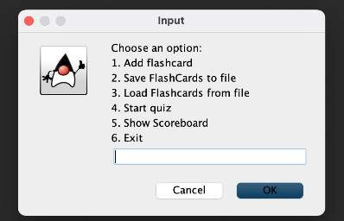

1. You choose "Add flashcard" and input the question "What is the capital of France?" and the answer "Paris". A message appears, saying that the flashcard is added.

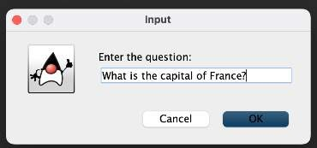

"Paris." The next flashcard is shown automatically.

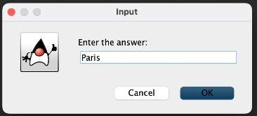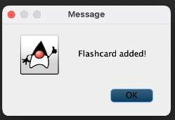

1. You choose "Add flashcard" again and input the question "What is 7 + 3?" and the answer "10". Another message appears, saying that the flashcard is added.

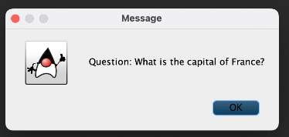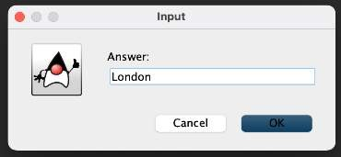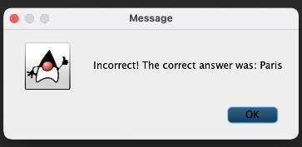

d. You enter "10" as the answer to "What is

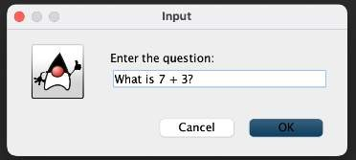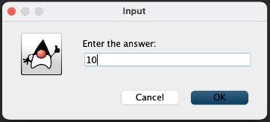

7 + 3?", which is correct. The program displays a message saying it's correct, and the next flashcard is shown.

1. Now you choose "Start quiz." The program displays the first flashcard's question, "What is the capital of France?" You enter "London" as the answer, which is incorrect. The program displays a message saying it's incorrect and shows the correct answer

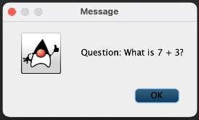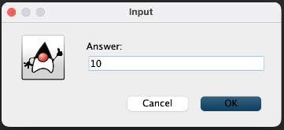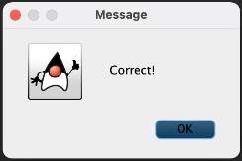

1. After answering all the flashcards, the quiz ends. The program prompts you to enter your name. You enter "John."

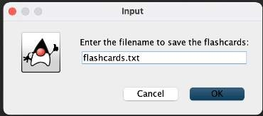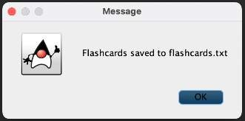

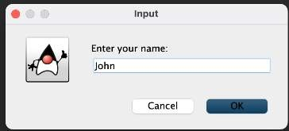

1. The program calculates your score and displays your name, score, and percentage on the screen.

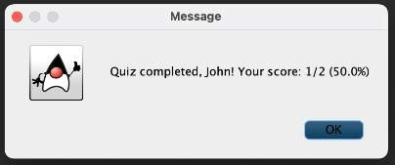

1. You can now choose "Show scoreboard" to see the top 5 scorers. If you haven't taken the quiz yet, it will show that there are no scores to display.

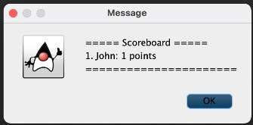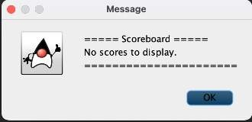

1. Next, you choose "Save FlashCards to file" and enter "flashcards.txt" as the filename. The flashcards you have added are saved to this file.
2. Later, you choose "Load Flashcards from file" and enter "flashcards.txt" as the filename. The flashcards you previously saved are loaded back into the program.

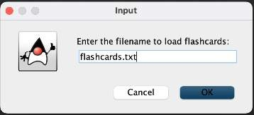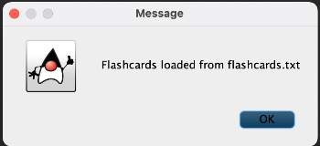

1. You can continue to add more flashcards, take the quiz again, and see the scoreboard with updated scores.

After investing significant time and effort, we are delighted to announce the completion of the FlashQuiz program, an interactive quiz application built in Java with the ACM graphics library. We faced challenges in handling user inputs, graphics implementation, and data management, but perseverance allowed us to deliver a user- friendly and visually appealing experience. The program now provides immediate feedback on quiz responses, tracks user scores, supports saving and loading flashcards to/from files, and showcases a top

scorer's scoreboard. We are grateful for the support from the open-source community and envision FlashQuiz as a valuable learning tool, offering an enjoyable way for users to enhance their knowledge. We eagerly anticipate sharing this project with the world, hoping it brings joy and learning to countless individuals.

# VI.

**Conclusion/Future Framework**

In conclusion, our proposed project aims to develop FlashQuiz, a user-friendly program designed to assist students in improving their retention of information and creating effective study materials. By utilizing a flashcard-based quiz system, FlashQuiz offers an engaging and interactive learning experience. The incorporation of a score calculator allows users to monitor their progress and identify areas for improvement. Additionally, the inclusion of a leaderboard fosters friendly competition among peers, motivating students to achieve higher scores.

Looking ahead, the future framework for FlashQuiz includes a set of enhancements that will further enhance its functionality and user experience. We plan to improve the graphical aspect of the program, making it visually appealing and intuitive, while also ensuring seamless accessibility across various devices and screen sizes.

Advanced quiz features will be introduced, such as adaptive quizzing, multimedia support, and randomized question order, to enhance learning outcomes and prevent rote memorization. Gamification and social

features will be integrated, with expanded leaderboard statistics, achievements, and collaborative study options to keep users engaged and motivated.

To support the learning process, data analytics will be leveraged to provide users with insights into their study habits and personalized recommendations. FlashQuiz will aim to be inclusive and accessible, offering support for users with disabilities and providing language options for an international audience.

We envision FlashQuiz being a part of the educational ecosystem, with integrations to popular learning management systems and educational platforms, as well as a content marketplace for users to access premium study materials.

Continuous improvement and user feedback will be at the core of FlashQuiz's development, ensuring that it remains a versatile and effective learning tool. By incorporating these future enhancements, FlashQuiz seeks to empower students in their academic journey, making learning more enjoyable, engaging, and productive.

**References (at least 10)**

1. Elmes, D. (n.d.). Anki: A program to improve your memory and enhance your learning. Retrieved from https://apps.ankiweb.net/
2. Sutherland, A., Margulius, D., & Cutler, T. (2012). Quizlet: A collaborative learning platform for creating and sharing study materials. In Proceedings of the 21st ACM

International Conference on Information and Knowledge Management (CIKM '12).

1. Cram. (n.d.). Flashcard app. Retrieved from

https://[www.cram.com/](http://www.cram.com/)

1. Gupta, C. (2023, February 21). Four Pillars of OOPs (Object Oriented Programming). Data Trained Blogs. https://datatrained.com/post/four- pillars-of- oops/#:~:text=The%20Four%20pillar s%20of%20OOPs%2C%20abstracti on%2C%20encapsulation%2C%20i nheritance%2C,to%20understanding

%20and%20using%20OOP.

[5 Herrity, K. (n.d.). What Is Object- Oriented Programming (OOP)? A Complete Guide. Indeed.Com. Retrieved August 3, 2023, from https://[www.indeed.com/career-](http://www.indeed.com/career-) advice/career-development/what-is- object-oriented-programming

1. Development, P. (n.d.). *What are some benefits and challenges of using flashcards as a learning tool?*

Retrieved August 3, 2023, from https://[www.linkedin.com/advice/0/w](http://www.linkedin.com/advice/0/w) hat-some-benefits-challenges-using- flashcards

1. Dutta, A. (2021, August 16). *Flashcards as a teaching*. https://[www.evelynlearning.com/flas](http://www.evelynlearning.com/flas) hcards-as-a-teaching-tool/
2. Team, M. (2022, August 27). *Why Your Students Should Be Using Flashcards*. Caduceus International Publishing. https://[www.cipcourses.com/blog/wh](http://www.cipcourses.com/blog/wh) y-your-students-should-be-using- flashcards/
3. Cabatuan, M. (n.d.). *LBYCPEI- Laboratory-Manual-1st-term-AY- 2022-23*.
4. Cabatuan, M. (n.d.). *OOP Terms and the Four Pillars*. Google Docs. Retrieved August 3, 2023, from https://docs.google.com/presentation

/d/1W1zaje6KoWWCPARd0IOEP1- tvgUAHcjPFKCNylyoeSI/edit#slide=i d.